|  |  |  |
| --- | --- | --- |
| Australian Government Net Zero Economy Authority | | |
| Official | | |
| Energy Industry Jobs Plan consultation paper | |  |
| Australia’s energy transition is a significant source of economic opportunity for our industries, regions and workers. | **netzero.gov.au** | |



Torrens Island Power Station

Contents

Have your say 3

Who we want to hear from 3

Key dates 3

How to make a submission 3

Contact 4

Introduction 5

What is Torrens Island Power Station? 5

What is the Energy Industry Jobs Plan? 5

Discussion questions 10

Beyond the scope of this paper 10

Submission guidelines and information 11

Publication of submissions 11

Energy Industry Jobs Plan – Privacy Collection Notice 11

## Have your say

The Energy Industry Jobs Plan is an Australian Government initiative to support workers affected by the closure of coal-fired or gas-fired power stations, where additional supports are needed.

The Net Zero Economy Authority is seeking feedback on the Energy Industry Jobs Plan in the context of the closure of Torrens Island Power Station in Adelaide, South Australia. Torrens Island Power Station is a gas-fired power station scheduled to close in June 2026. The purpose of this consultation is to inform an assessment process the Authority is undertaking to determine if the Energy Industry Jobs Plan needs to be implemented for this closure.

### Who we want to hear from

We’d like to hear from people and stakeholders impacted by the closure of Torrens Island Power Station. This could include, but is not limited to:

* workers at Torrens Island Power Station
* workers at businesses associated with Torrens Island Power Station
* employers who may be impacted by the closure
* other employers in the region, particularly employers who may be interested in taking on workers from the station once it has closed
* First Nations representatives in the region
* employer organisations
* unions
* community groups
* members of the broader Adelaide community.

We have included discussion questions in this consultation paper to help guide the feedback you may wish to provide.

### Key dates

Submissions on this consultation paper are due on **21 February 2025.**

In addition to seeking feedback through this consultation paper, we will be conducting in-person and online consultation meetings with affected stakeholders in early 2025. This will include consultation with groups outlined under section 55 of the *Net Zero Economy Authority Act (2024)*.

### How to make a submission

You can submit feedback to the Authority via email at [EIJP@pmc.gov.au](mailto:EIJP@pmc.gov.au), either in written form or an accessible audio-visual file. We will notify you that we have received your submission within 3 business days.

Responses can also be posted to:

Energy Industry Jobs Plan – Torrens Island Power Station Consultation

Net Zero Economy Authority

PO Box 6500 CANBERRA ACT 2600

We recommend that submissions are concise and address the discussion questions outlined in the paper.

**Non-confidential submissions made as part of this consultation process will be published on the Authority’s website.** Further information on the publication process is on page 11.

### Contact

For questions or general enquiries on the consultation process, please contact [EIJP@pmc.gov.au](mailto:EIJP@pmc.gov.au). Responses will be provided within 3 business days.

## Introduction

### What is Torrens Island Power Station?

Torrens Island Power Station is an 800MW gas-fired power station in Adelaide, South Australia. The power station has approximately 130 workers and is owned and operated by AGL.

The power station comprises two parts, Torrens ‘A’ and Torrens ‘B’. The four 120MW generating units comprising Torrens 'A' were progressively closed from September 2020, with the final unit formally closing in September 2022. One of the 200MW generating units of Torrens 'B' was mothballed in 2021 due to adverse market conditions.

AGL notified the Australian Energy Market Operator (AEMO) in November 2022 that the remaining three 200MW units at Torrens ‘B’ will retire on 30 June 2026.

More information on Torrens Island Power Station is available on [AGL’s website](https://www.agl.com.au/about-agl/how-we-source-energy/agl-torrens?srsltid=AfmBOoo4kFP40EVqqvwUPl2CATzolx-VOhdjISOE7JDrTf2MMXZKyteh).

### What is the Energy Industry Jobs Plan?

Most of Australia’s coal-fired power stations and some gas-fired power stations have announced closure dates. To assist a smooth transition for these workers and their communities, additional support may be needed to help workers to consider their next career step, retrain and find new employment.

The Energy Industry Jobs Plan provides support directly to workers to prepare for and transition into a new job when eligible coal-fired or gas-fired power stations close. This support can extend to employees in businesses working directly with the power station, where their operations will be substantially impacted by the closure (known as ‘dependent employers’). For example, a coal mine that supplies a power station.

The Energy Industry Jobs Plan is a legislated program established under the *Net Zero Economy Authority Act 2024*.

#### How does the process work?[1]

The Energy Industry Jobs Plan is one form of support that may be available to workers in the event of a power station closure.

To determine whether it is applied, the Authority undertakes a thorough assessment process to determine if the Energy Industry Jobs Plan is needed for a particular power station closure. This includes consultation with the closing power station, dependent businesses, unions, employer organisations, potential new employers and the community.

The focus of these consultations is understanding how workers and businesses are impacted, what support workers can already access, and what other employment opportunities exist in the region. It also seeks to understand where the Energy Industry Jobs Plan could add value, including through obligations on employers to provide training and other supports, and a program led by the Authority to help workers connect with potential new job opportunities.

If the assessment process indicates the Energy Industry Jobs Plan is needed for an upcoming closure, the Authority will make an application to the Fair Work Commission.

If the Fair Work Commission decides the Energy Industry Jobs Plan will be implemented for a closure, the Authority will then work with the relevant employers and workers to ensure supports are provided in the lead up to the closure.

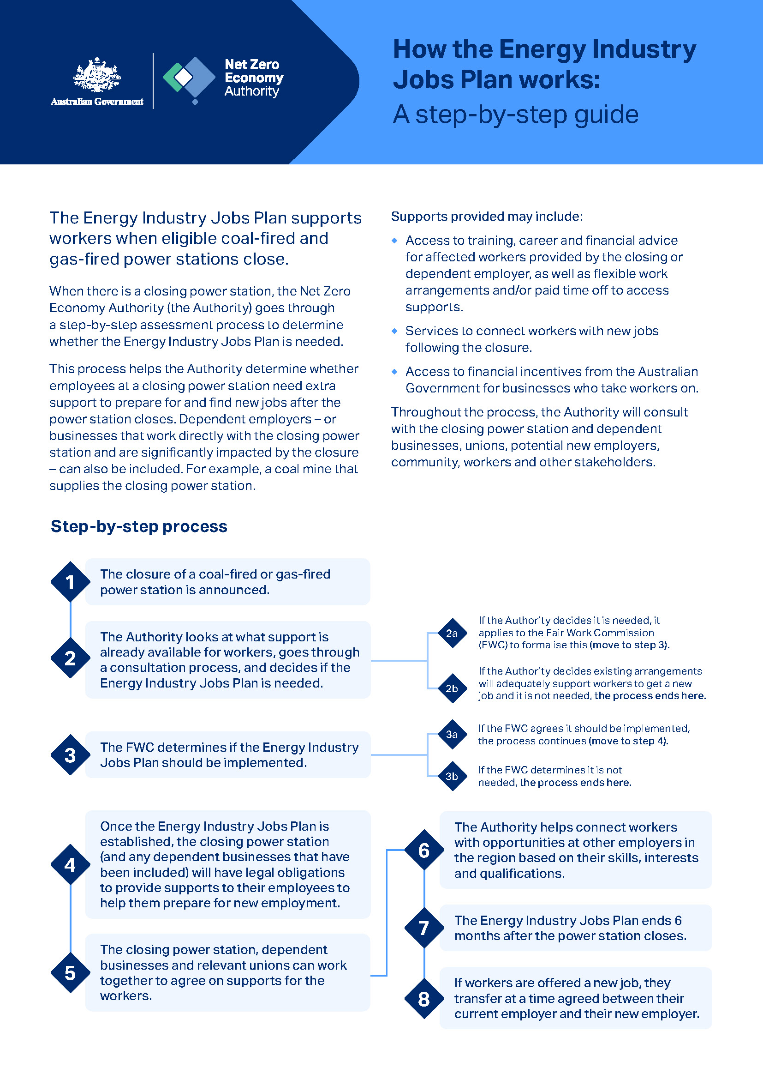

#### When does this process start?

The *Net Zero Economy Authority Act 2024*, which came into effect in December 2024, specifies that any application to the Fair Work Commission to implement the Energy Industry Jobs plan must generally be made at least two years before the power station’s scheduled closure date.

This process has been designed to help give workers more certainty on their next career steps after a closure. By putting a plan in place early, ideally several years out from a closure, workers will have time to meaningfully retrain or upskill for new career opportunities.

Given the legislative framework has only just been established, the process for Torrens Island is occurring less than two years out from the announced closure date and will aim to be completed as soon as practicable.

Sometimes, the announced closure date of a power station can also change. There are a range of factors that can impact this decision. Where the scheduled closure date of a station changes, the Authority will work with the impacted parties to understand the implications and next steps.

#### What support may be available for workers?

Under the Energy Industry Jobs Plan, employers are required to provide support to employees to prepare them to find and obtain a new job. This process starts well in advance of the planned closure.

The types of support employers will be required to offer to workers can include:

* access to training to prepare for a future job
* career planning
* financial advice
* paid leave and/or flexible work arrangements to access these supports.

The specific supports workers can access will depend on the needs of the business and needs of the employee, as well as supports included in enterprise agreements and other industrial instruments. There are pathways through the Fair Work Commission for employers and unions to agree on what actions constitute meeting obligations under the Energy Industry Jobs Plan.

Ahead of the closure, the Authority will work to connect workers with other employment opportunities in the region that align with their skills and experience. This will be supported by coordinators working on the ground directly with workers and employers who volunteer to offer redeployment opportunities. Employers who take on workers from closing facilities may be eligible for incentive payments from the Australian Government.

While the workforce at each power station is different, workers often have skills and qualifications in roles such as power plant generation operators, fitters, metal fabricators, electricians, engineers (electrical, mechanical), electrical engineering technicians, program or project administrators, specialist managers, accountants, and general clerks, amongst other roles.

For more information on the Energy Industry Jobs Plan, please visit the [Net Zero Economy Authority website](https://www.netzero.gov.au/power-station-closure-plans).

#### How is it determined which employers are included under the Energy Industry Jobs Plan?

There are two categories of employers that can be included under the Energy Industry Jobs Plan: closing employers and dependent employers.

A closing employer is generally the owner or operator of the closing power station.[2]

Businesses within a closing power station’s supply chain can also be included as a ‘dependent employer’ under the Energy Industry Jobs Plan in some circumstances. Dependent employers, like closing employers, are required to provide transition supports to their workforce to help them prepare for new jobs following the closure. A business has to meet certain criteria under the Act to be considered a dependent employer:

* The business must be a constitutional corporation.
* The business must have a commercial relationship with the closing power station (or coal mine that supplies the power station).
* The employer will, or will be likely to, cease a substantial part of their business in their region as a direct result of the closure.

The Act does not provide a threshold for the level of business operations that have to cease for it to be considered a ‘substantial part’ of business operations. This is assessed on a case-by-case basis and will consider the relevant contexts of the closing power station, the potential dependent employer and its business operations, and its employees.

The Net Zero Economy Authority’s research and engagements to date indicate it may be unlikely any businesses within the supply chain of Torrens Island Power Station will qualify as a ‘dependent employer’ under the Energy Industry Jobs Plan. However, this will be confirmed as part of the current consultation process.

#### Proposed geographic area

As part of assessing if a power station should be included in the Energy Industry Jobs Plan, a geographic boundary is put around the closing power station to limit where the program will apply.

This area is designed to capture the closing site, as well as the locations where any dependent employers (such as a coal mine) might operate. It also helps inform our analysis of the local labour market and the ability for workers to find employment in their region, considering factors like reasonable commute time and the locations of other businesses that may be able to offer employment.

We are currently proposing to include the below areas in the geographic area for Torrens Island Power Station:

* Adelaide City
* Burnside
* Campbelltown (SA)
* Norwood – Payneham – St Peters
* Prospect – Walkerville
* Unley
* Gawler – Two Wells
* Playford
* Port Adelaide – East
* Salisbury
* Tea Tree Gully
* Holdfast Bay
* Marion
* Mitcham
* Charles Sturt
* Port Adelaide – West
* West Torrens

As part of this consultation process, we are interested in hearing from affected stakeholders to understand if this geographic area will best support the Energy Industry Jobs Plan for Torrens Island Power Station.

**Figure 1:** Proposed areas for inclusion in the geographic area for Torrens Island Power Station

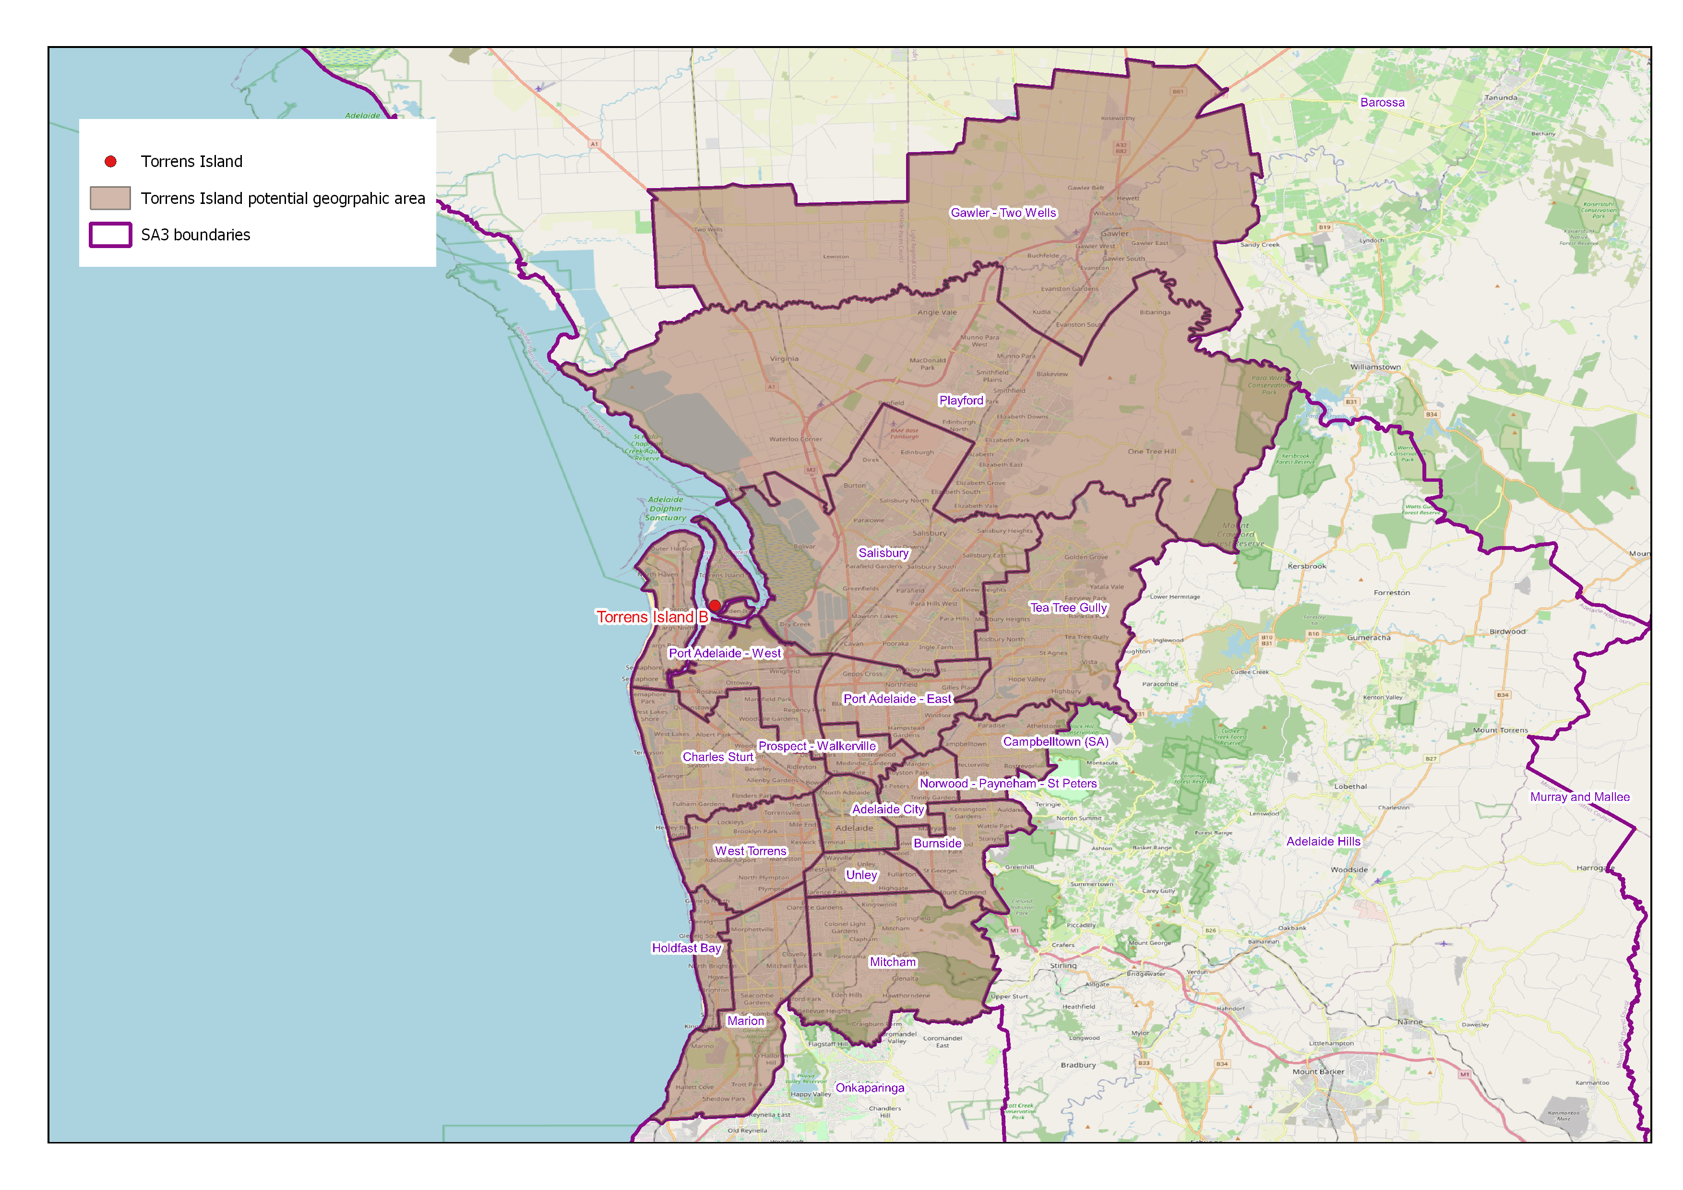

## Discussion questions

This consultation paper is seeking feedback on the Energy Industry Jobs Plan in the context of the closure of Torrens Island Power Station in South Australia.

We have provided questions we would like to hear from you below. Please note these are a guide, and we welcome any feedback you would like us to consider when assessing the Energy Industry Jobs Plan at Torrens Island Power Station.

You can respond to each of these questions individually in your submission, or consider them in an overarching response to this consultation paper. Where you have referred to a data or information source, please include the details of this source in your submission.

1. How will the closure of Torrens Island Power Station impact you, either personally, as a community, or as an organisation?
2. Do you think that workers at Torrens Island B and other impacted businesses will be able to find and transition into new employment in the Adelaide region quickly once the station closes?
   1. Are there jobs that workers could transition into that require the same or similar skillsets they currently have?
   2. Are there any particular barriers to finding new employment for these workers?
3. What supports are currently being offered to workers at Torrens Island B to help them prepare for their next career step once the power station closes?
   1. Who are these supports being provided by?
   2. Are there any gaps in the current supports available to these workers?
4. Would the establishment of an EIJP support a smoother transition for impacted workers and their local community?
5. For businesses in the Adelaide region:
   1. How many workers are you looking to hire over the next 18-24 months? What specific skills are you seeking, which occupations do you need filled, and what level of experience are you looking for in a worker?
   2. Would you consider hiring workers from Torrens Island Power Station? What information or support would you need to make decisions about hiring these workers? What would discourage you from hiring workers?
6. Do you think the current geographic area will accurately support local labour market analysis for Torrens workers?

### Beyond the scope of this paper

This consultation paper is seeking input on the Energy Industry Jobs Plan in the context of Torrens Island Power Station in Adelaide, South Australia. The following is outside of the scope of this paper:

* the overall design and remit of the Energy Industry Jobs Plan as a program
* the other functions and broader remit of the Net Zero Economy Authority
* other power station closures
* other government policies.

## Submission guidelines and information

### Publication of submissions

To support transparency in the Community of Interest process, generally the Net Zero Economy Authority will publish non-confidential submissions on its website.

If a submission is published on the Net Zero Economy Authority website, the information in it, including the name of the person lodging the submission, can be searched for on the internet, including from overseas.

We may choose not to publish submissions on our website at our discretion, or to withhold certain content in submissions from publication (e.g. by removing defamatory material from the published version of submissions, or where appropriate, de-identifying personal or sensitive information).

Additionally, we will not publish confidential submissions. To claim confidentiality on behalf of a person or an organisation, the first page of a submission should clearly state the content that should be treated as confidential (e.g. an individual’s name, so that it is not published on the internet). The option also exists to place confidential information in an attachment to a submission, with a request to keep the attachment confidential.

Confidential submissions will only be reviewed by relevant staff at the Net Zero Economy Authority and will not be released on the website. De-identified summaries of these submissions will not be made public without permission of the submitter. The NZEA may provide confidential submissions to the Fair Work Commission on a de-identified and/or confidential basis, but will contact the submitter before providing such submissions to the Fair Work Commission.

Submissions can be made anonymously. However, as we may be unable to verify or clarify the information provided in anonymous submissions, this may impact how we consider the submissions as part of the open consultation process.

Any submission to the Net Zero Economy Authority on the Energy Industry Jobs Plan may be subject to a request under the *Freedom of Information Act 1982* (Cth).

### Energy Industry Jobs Plan – Privacy Collection Notice

This Privacy Collection Notice relates to consultation processes under Part 5 of the *Net Zero Economy Authority Act 2024* (**the Act**).

Participation is voluntary, however if you do choose to participate in the consultation process, collection of your personal information may occur. Your personal information is protected by law, including under the *Privacy Act 1988* (Cth) (**Privacy Act**).

This privacy collection notice explains how the Net Zero Economy Authority will handle personal information it collects through the consultation process.

##### What type of information should I include in my submission?

Submissions may include [personal information](https://www.oaic.gov.au/privacy/your-privacy-rights/your-personal-information/what-is-personal-information) about you or someone else.

Members of the community can make submissions on an anonymous or confidential basis.

While we seek your opinions to inform the consultation process, personal information about anyone else is not required. When preparing your submission, you should minimise any personal information about other people. If you do provide information about any other identified or reasonably identifiable person, you must obtain their consent to do so and provide them with a copy of this privacy collection notice.

Any information in your submission must be, to your knowledge, accurate, up-to-date and complete.

##### What we collect

Through the consultation process, we will collect a range of personal information (some of which could be [sensitive information](https://www.oaic.gov.au/privacy/your-privacy-rights/your-personal-information/what-is-personal-information#SensitiveInfo)), including your:

* Name
* Contact information
* Organisation you represent and your role
* Your personal views or information about a particular power station closure being assessed under the Energy Industry Jobs Plan.

We may collect personal information from you as well as from other people. We do not require other personal information beyond what is listed above. In the instance that we do require further personal information for clarification or verification of your submission, we will seek this from you and provide a reason for why we need it.

##### How we collect your information

We will collect your personal information:

* directly from you through an email submission
* indirectly if another person includes your information in a submission, with your consent.

##### Why we collect your personal information

We will collect your personal information to inform the assessment process to determine if the Energy Industry Jobs Plan should be implemented for a gas-fired or coal-fired power station closure. This includes:

* gathering information we are required to consider in the Community of Interest process and our decision to apply to the Fair Work Commission under sections 55 and 56 of the Act
* meeting our consultation requirements under section 55 of the Act.

If you do not provide your personal information (including sensitive information), we will not be able to consider your views as part of the consultation process.

##### Who we disclose your personal information to

We may disclose your personal information to the Fair Work Commission as part of the Community of Interest process. We will seek your consent before we provide confidential parts of your submission to the Fair Work Commission.

If we wish to disclose your personal information to other entities, we will seek your consent prior to doing so.

Submissions published on our website will be accessible by individuals and entities outside Australia who are not bound by the Australian Privacy Principles. By providing your submission on a non-confidential basis, you consent to publication.

##### Storage of your personal information

We store your personal information securely in accordance with the Privacy Act and government requirements. For more details, see our Privacy Policy.

##### More information

More information about how we handle your personal information is set out in our Privacy Policy, including how to:

* access any personal information that we hold
* seek correction of personal information that we hold
* complain about a breach of the Australian Privacy Principles in the Privacy Act.

If you have any concerns or questions, you can contact us at [EIJP@pmc.gov.au](mailto:EIJP@pmc.gov.au).

1. The Energy Industry Jobs Plan is legislated under Part 5 of the [*Net Zero Economy Authority Act 2024*](https://parlinfo.aph.gov.au/parlInfo/search/display/display.w3p;db=LEGISLATION;id=legislation%2Fbills%2Fr7177_third-reps%2F0001;query=Id%3A%22legislation%2Fbills%2Fr7177_third-reps%2F0000%22#97f536a9f6f54a50bc58cc593c7f88a7). This section describes processes legislated under that part of the Act.
2. Under the Act, it can also include associated entities of the power station owner or operator that employ workers to perform work at the power station and any dependent mines.